**Ideation Phase**

**Empathize & Discover**

|  |  |
| --- | --- |
| Date | 27 JUNE 2025 |
| Team ID | LTVIP2025TMID20276 |
| Project Name | Citizen AI – Intelligent Citizen Engagement Platform |
| Maximum Marks | 4 Marks |

**Empathy Map Canvas:**

**🧍‍♀️ User Persona 1: Local Citizen**

|  |  |
| --- | --- |
| **Section** | **Insight** |
| **Says** | "Why doesn't anyone fix this?" "I reported this issue before and nothing happened." |
| **Thinks** | "Maybe no one will care even if I speak up." "Reporting is too complicated." |
| **Does** | Tries calling helplines, posts on social media, often gives up |
| **Feels** | Frustrated, ignored, powerless, disillusioned |

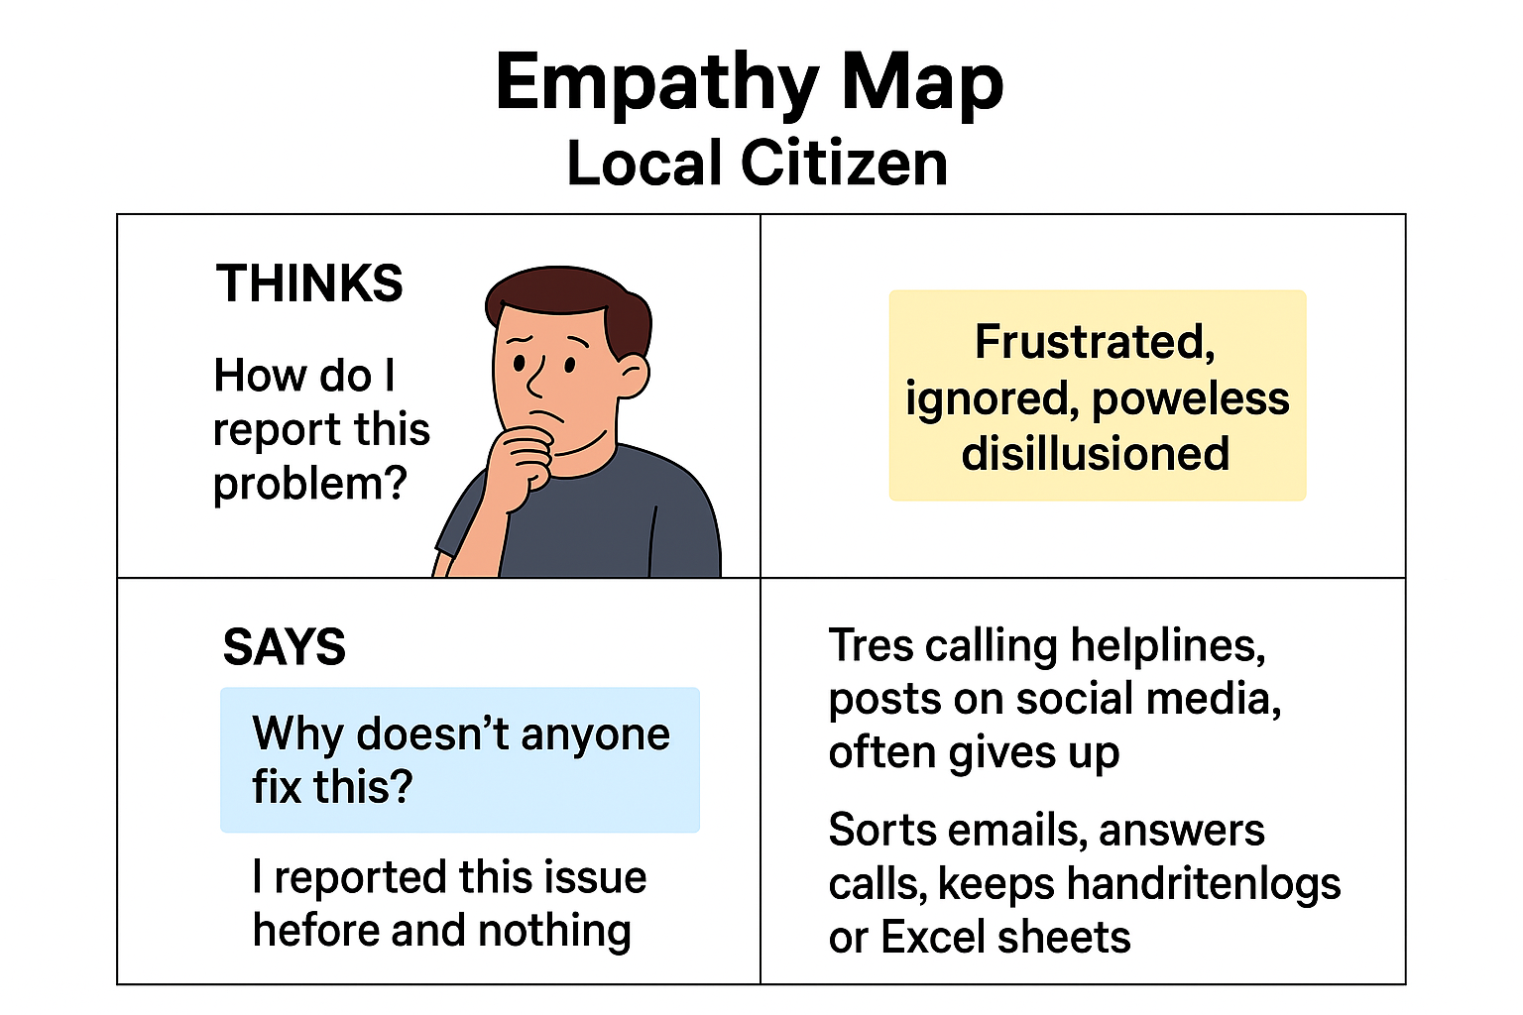

**🧑‍💼 User Persona 2: Municipal Officer**

|  |  |
| --- | --- |
| **Section** | **Insight** |
| **Says** | "People keep complaining, but I can't keep track of it all." "I wish I had a dashboard to summarize everything." |
| **Thinks** | "There's no easy way to filter what’s urgent or trending." "We're missing patterns in citizen feedback." |
| **Does** | Sorts emails, answers calls, keeps handwritten logs or Excel sheets |
| **Feels** | Overwhelmed, reactive, under-equipped |

